Week-03-Decision Making and Branching - if, if...else and nested if…else, if...else if and switch…case

Week 03-01-practice session coding

Reg no : 241801291

Name : TARRUN.B

Q1)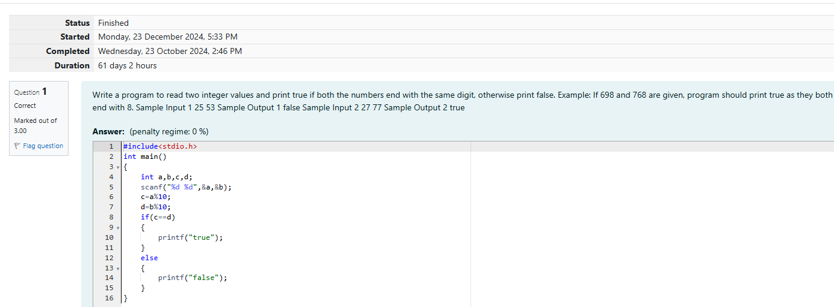

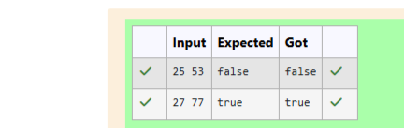

Week 03-01-practice session coding

Reg no : 241801291

Name : TARRUN.B

Q2)

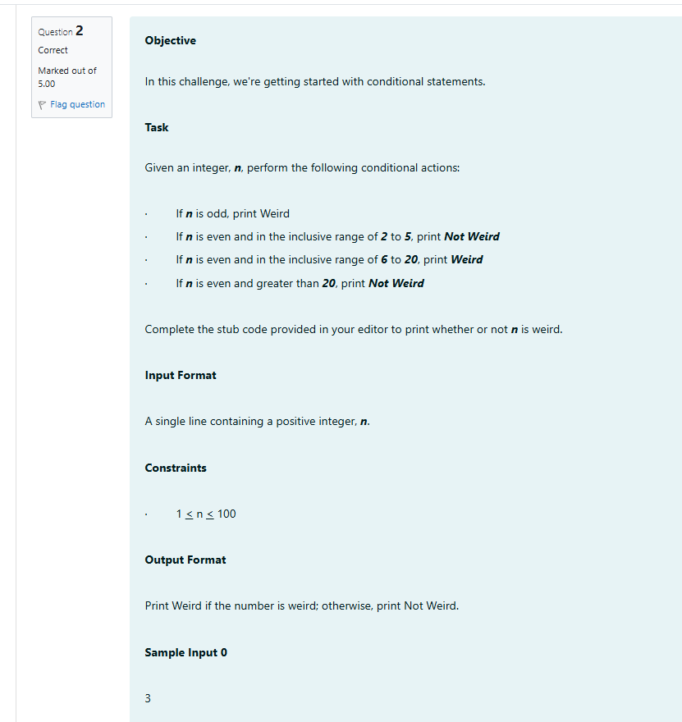

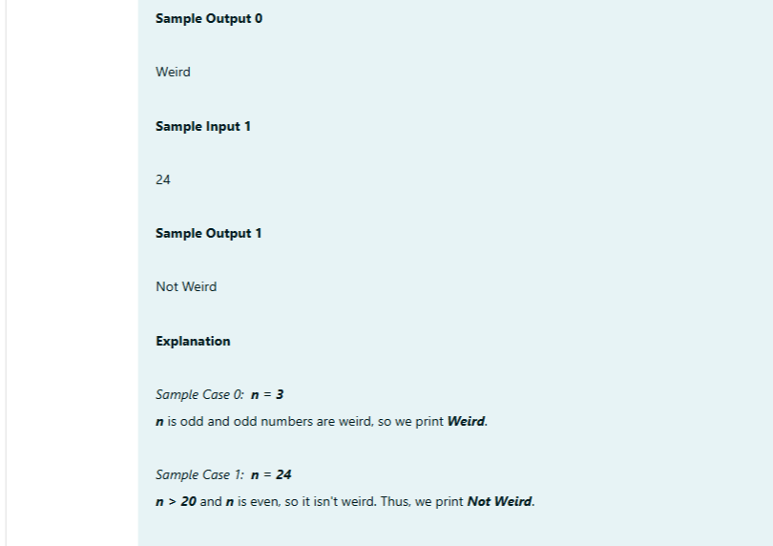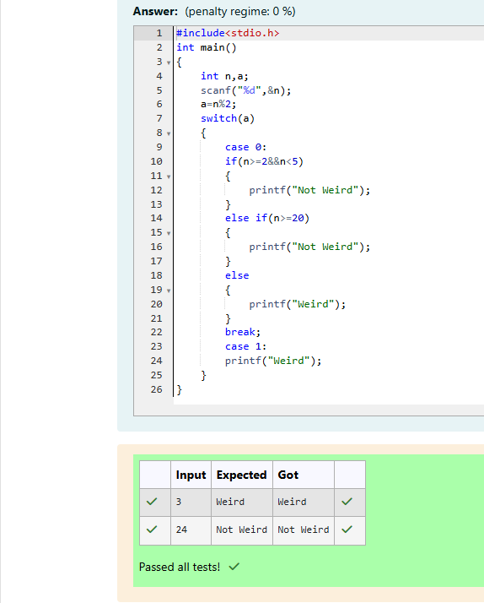

Week 03-01-practice session coding

Reg no : 241801291

Name : TARRUN.B

Q3)

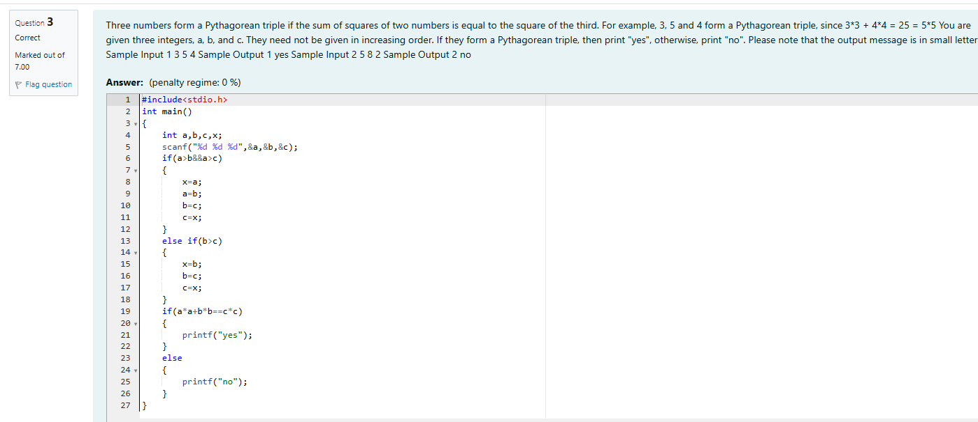

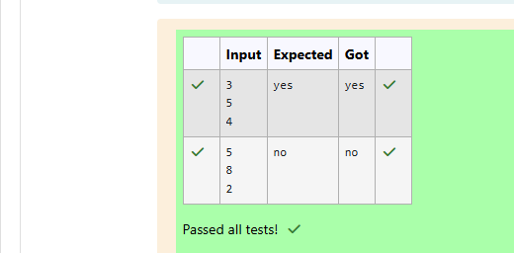

Week 03-02-practice session coding

Reg no : 241801291

Name : TARRUN.B

Q1) 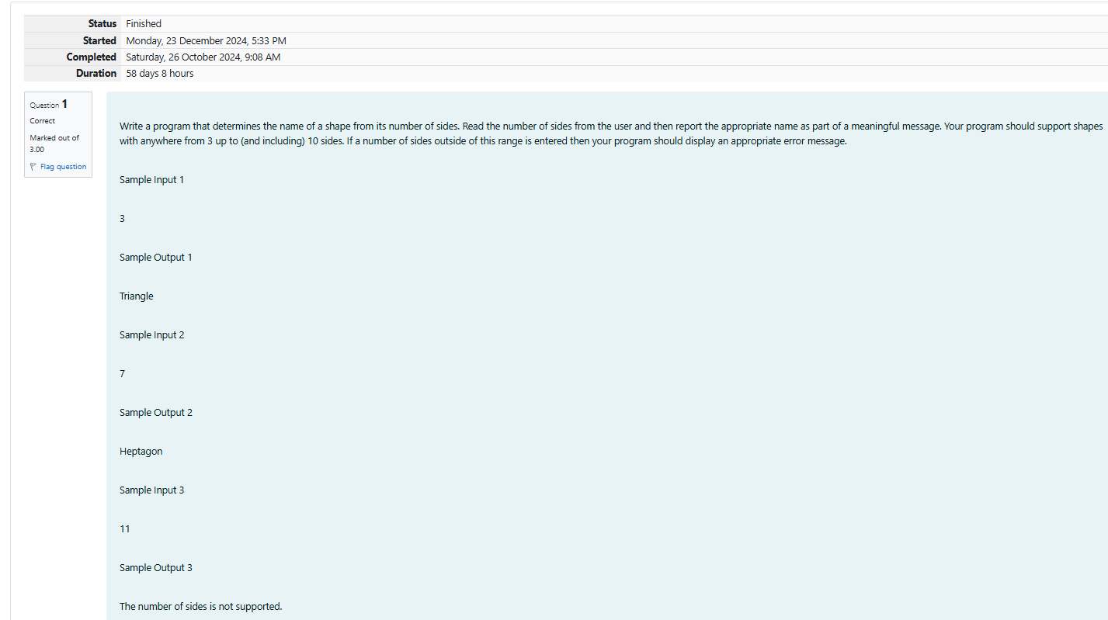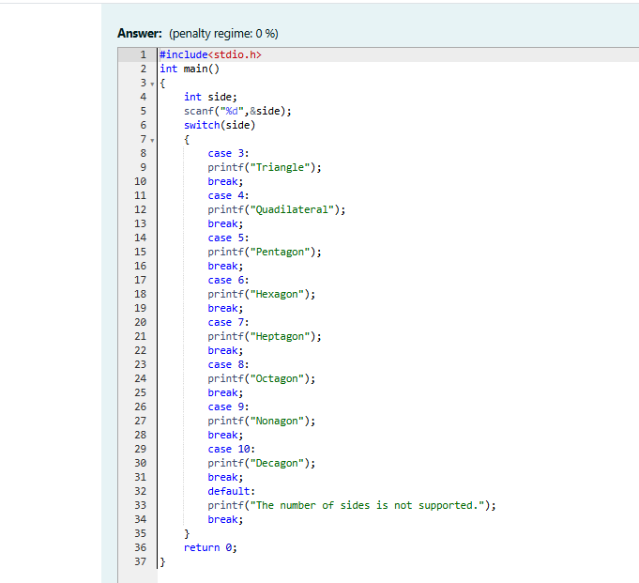

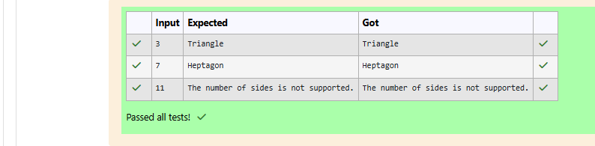

Week 03-02-practice session coding

Reg no : 241801291

Name : TARRUN.B

Q2)

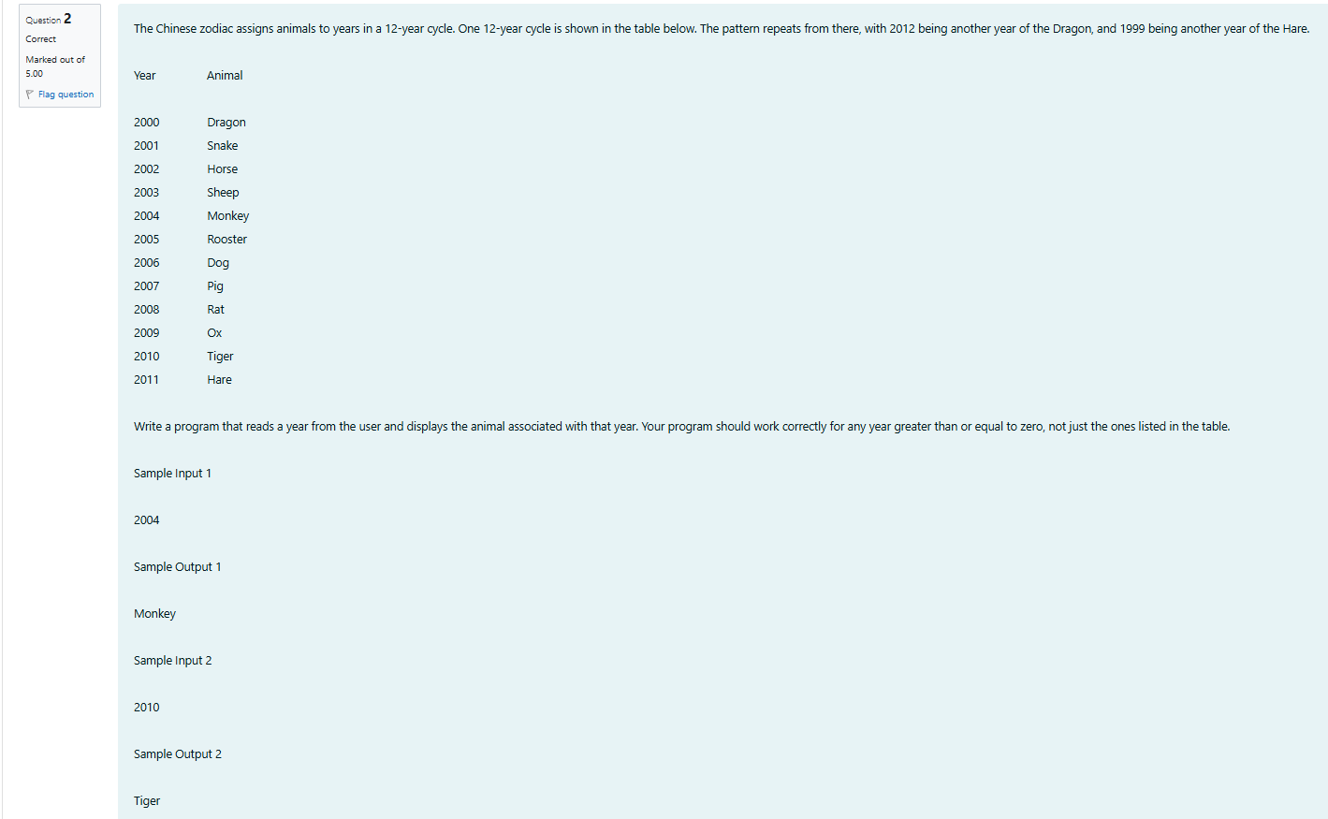

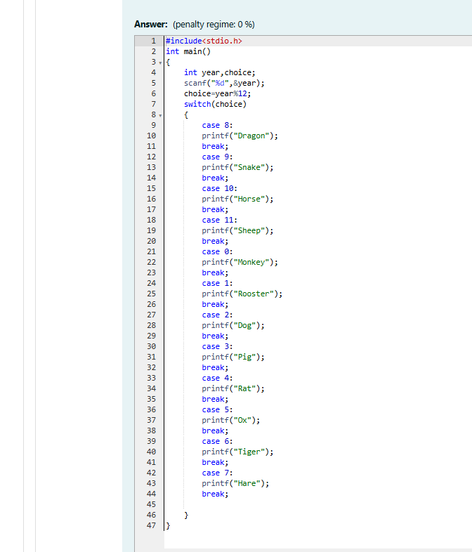

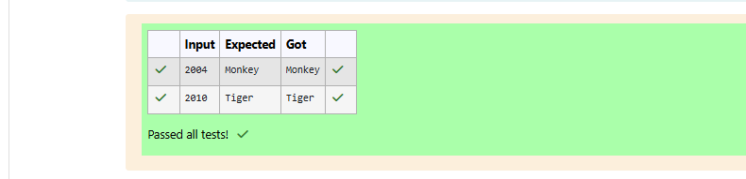

Week 03-02-practice session coding

Reg no : 241801291

Name : TARRUN.B

Q3)

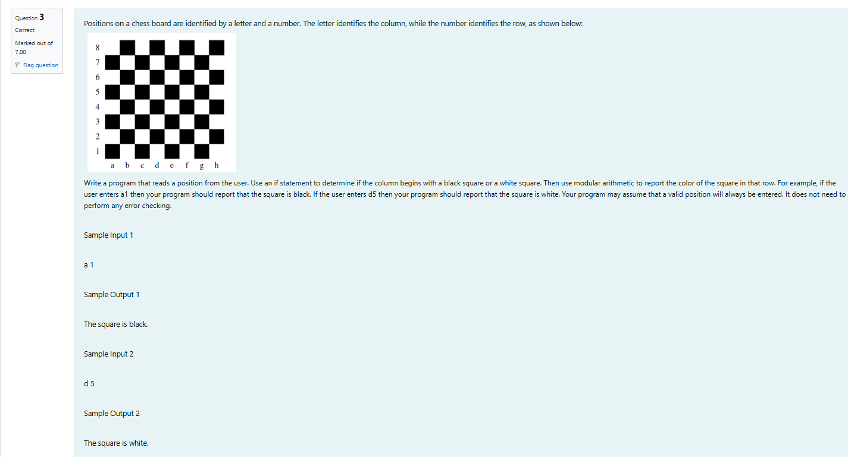

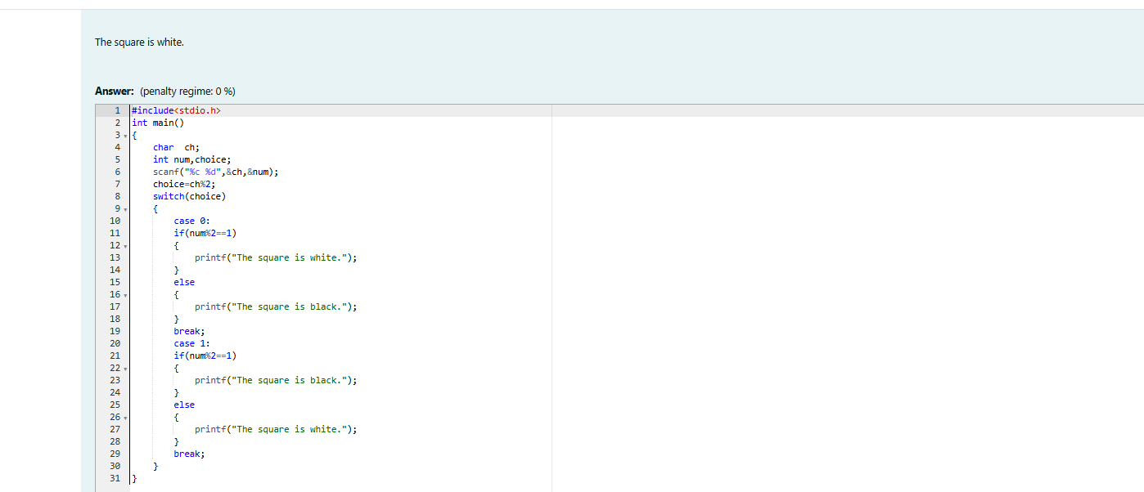

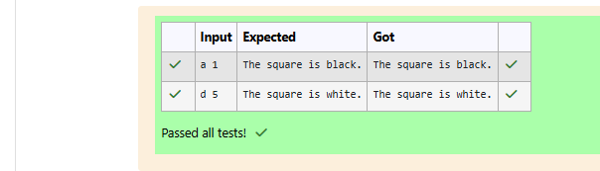

Week 03-03-practice session coding

Reg no : 241801291

Name : TARRUN.B

Q1)

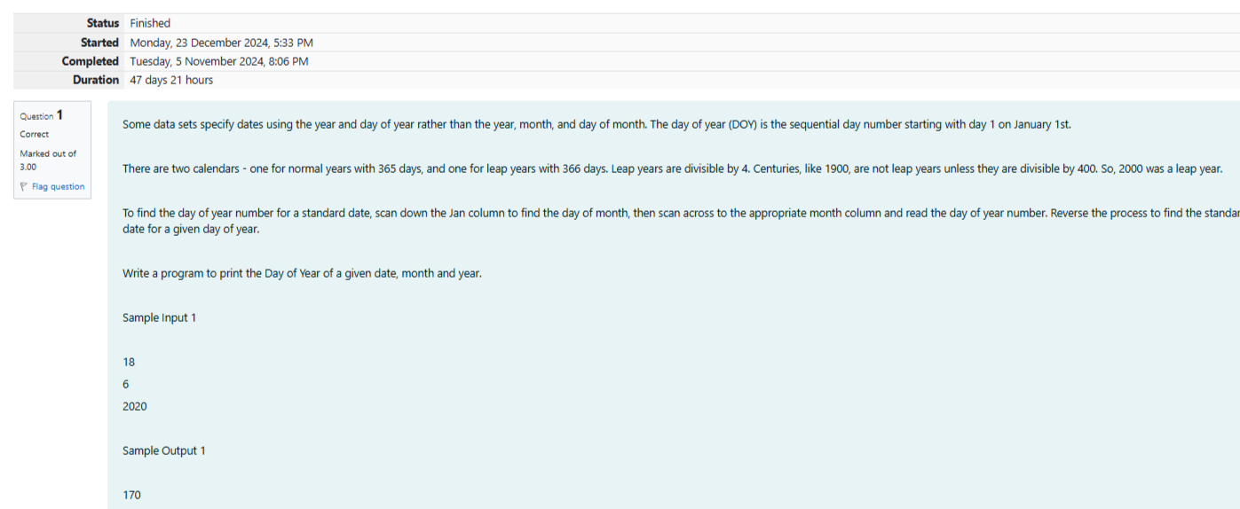

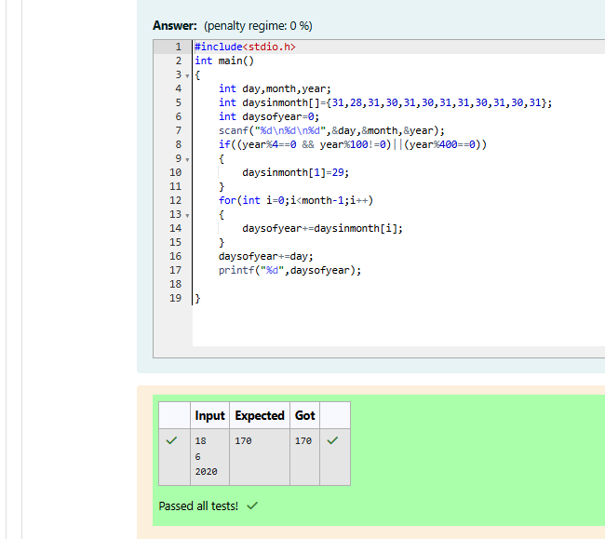

Week 03-03-practice session coding

Reg no : 241801291

Name : TARRUN.B

Q2)

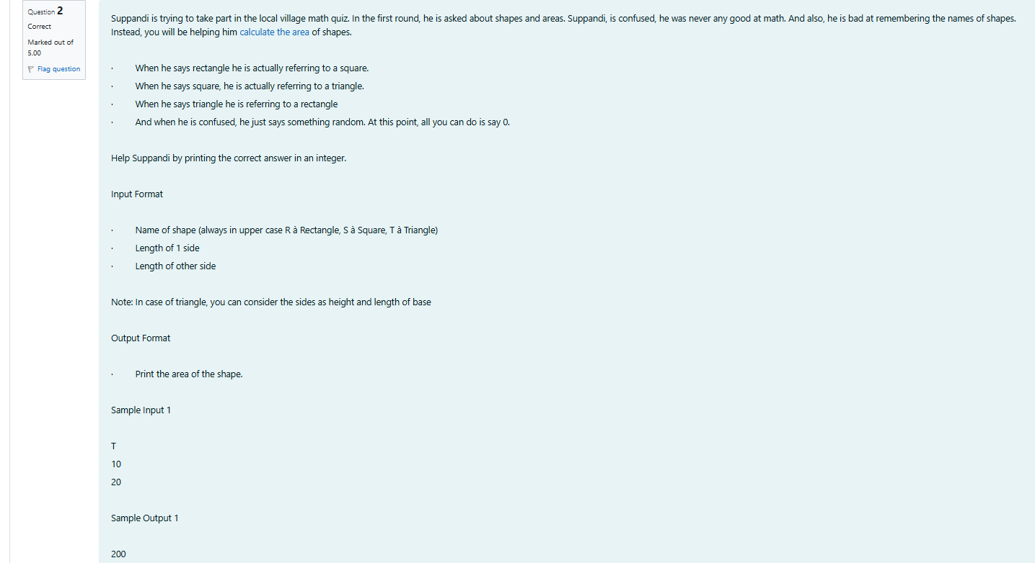

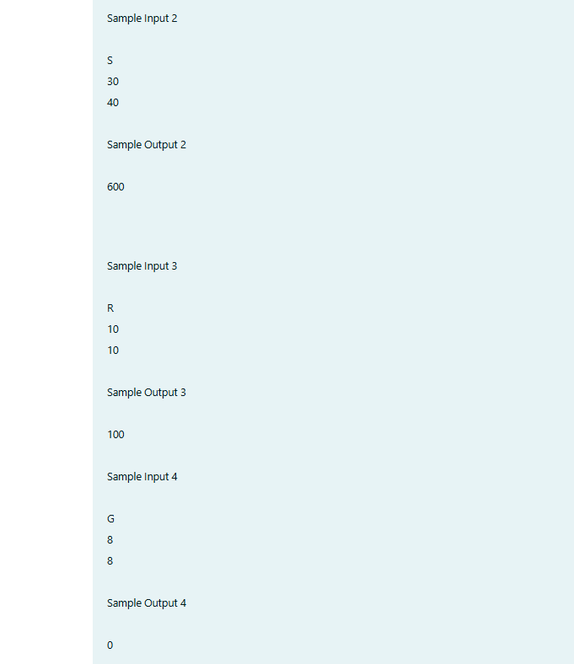

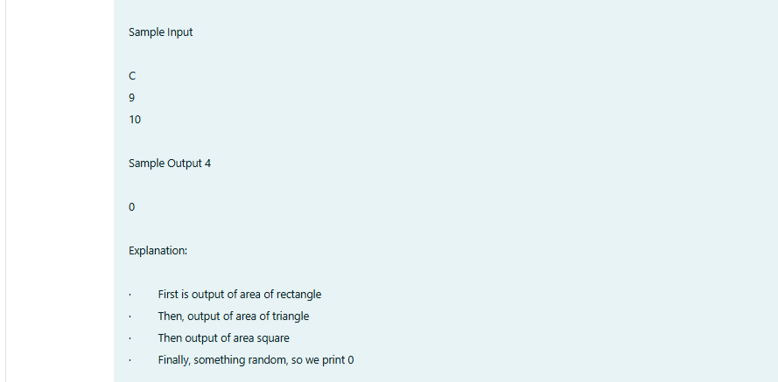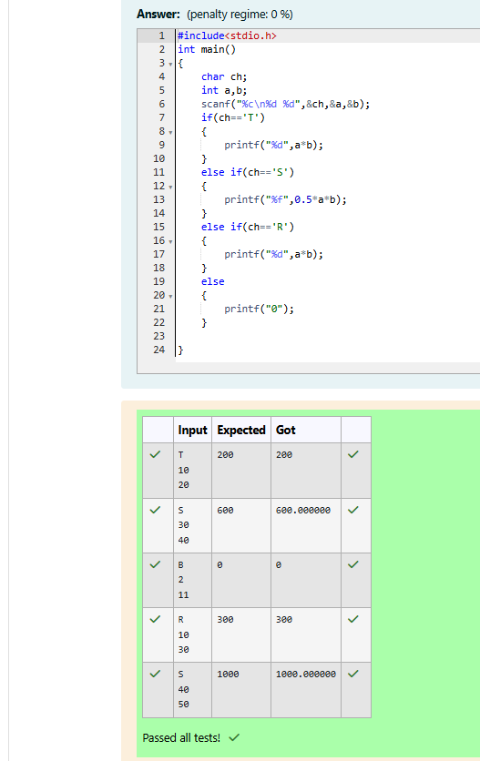

Week 03-03-practice session coding

Reg no : 241801291

Name : TARRUN.B

Q3)

